**Lab Assignment 5**

# **Hello World Django App**

Some necessary steps are required to follow to develop a simple Hello World Django app which consists of a single route & returns an object of JSON with a message of Hello World. In the below section, the steps are going to discuss in detail along with appropriate screenshots to better understand the developing activities.

Python is necessarily required to develop a Django app and to obtain a Hello World message. So, initially, in the command prompt window, it is checked if Python is installed in the system or not. Since as shown in the below screen Python version is obtained so Python is already installed presently in the system.

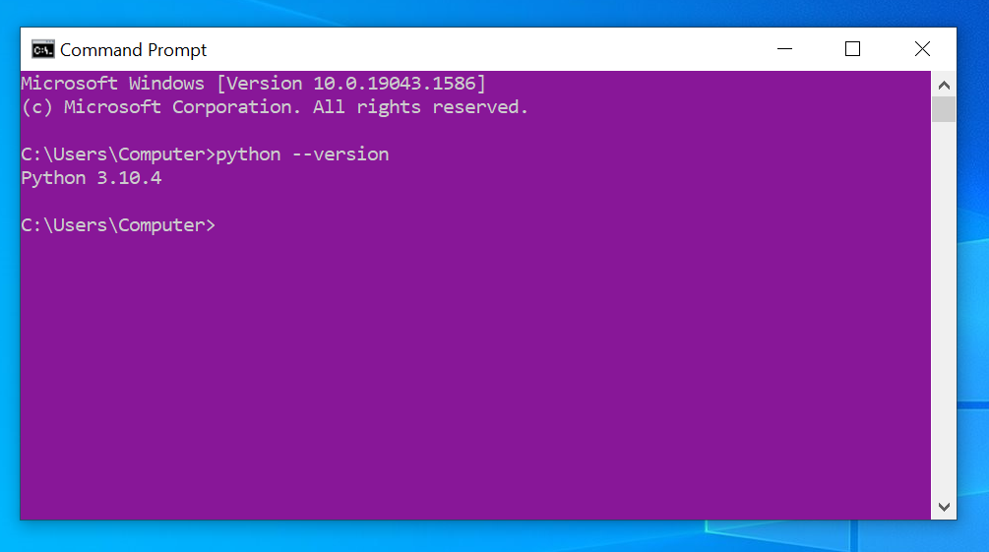

Afterward, in the download’s directory a helloworld! the directory is created as shown in the below snap.

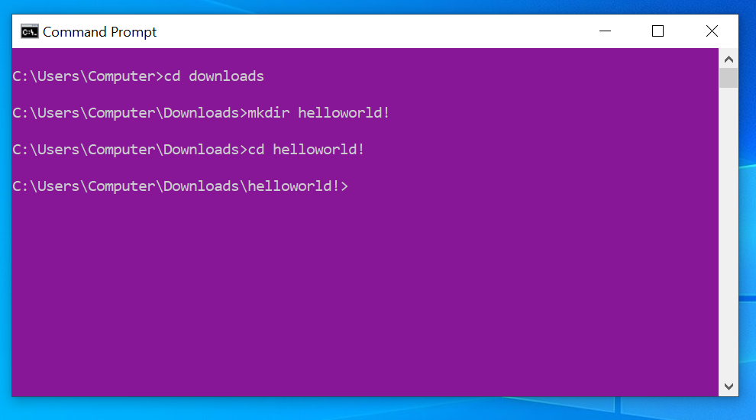

A new virtual environment which is a .venv is created inside the helloworld! directory and activate it by giving suitable commands as in the below screen.

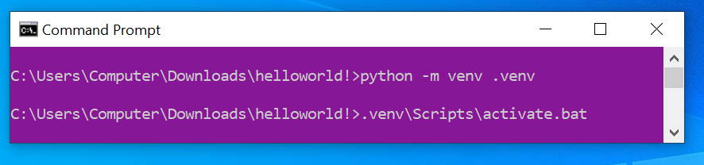

Afterward, by using the suitable command as shown below Django version of 4.0.4 is successfully installed.

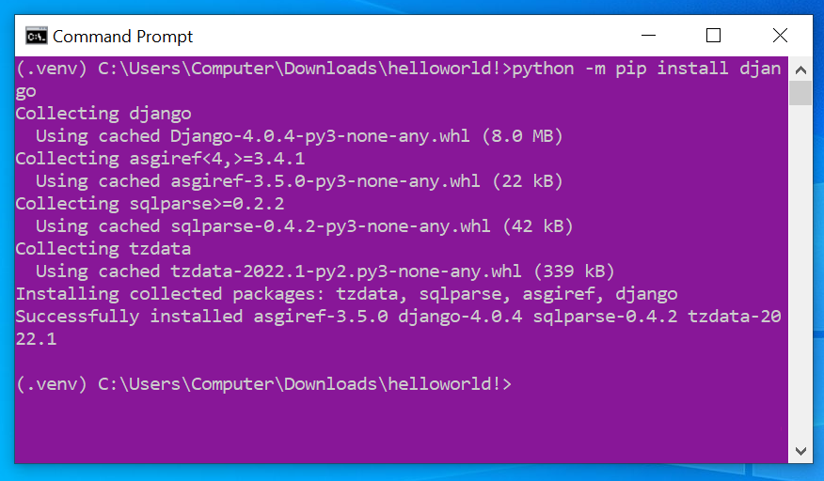

Now, the Django command called startproject is used to create a new project namely webapp (Ogbopina, 2019).

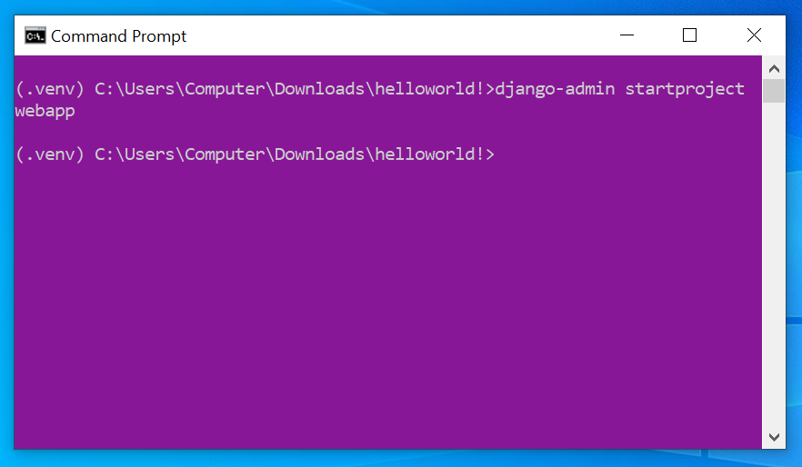

Once the above command is given a below-shown project structure is present inside the webapp project which is provided by Django.

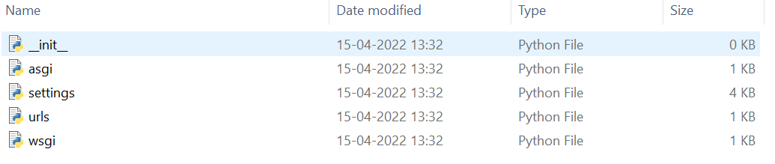

Then the command of python manage.py runserver is given as in the below snap. As a result, an URL is obtained.

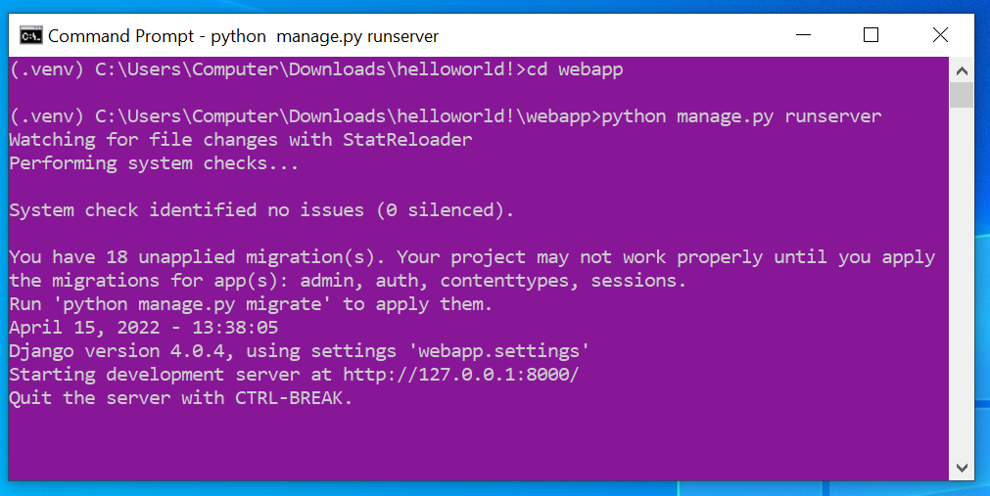

By visiting the obtained URL in the web browser, the below screen of Django install worked successfully message is obtained.

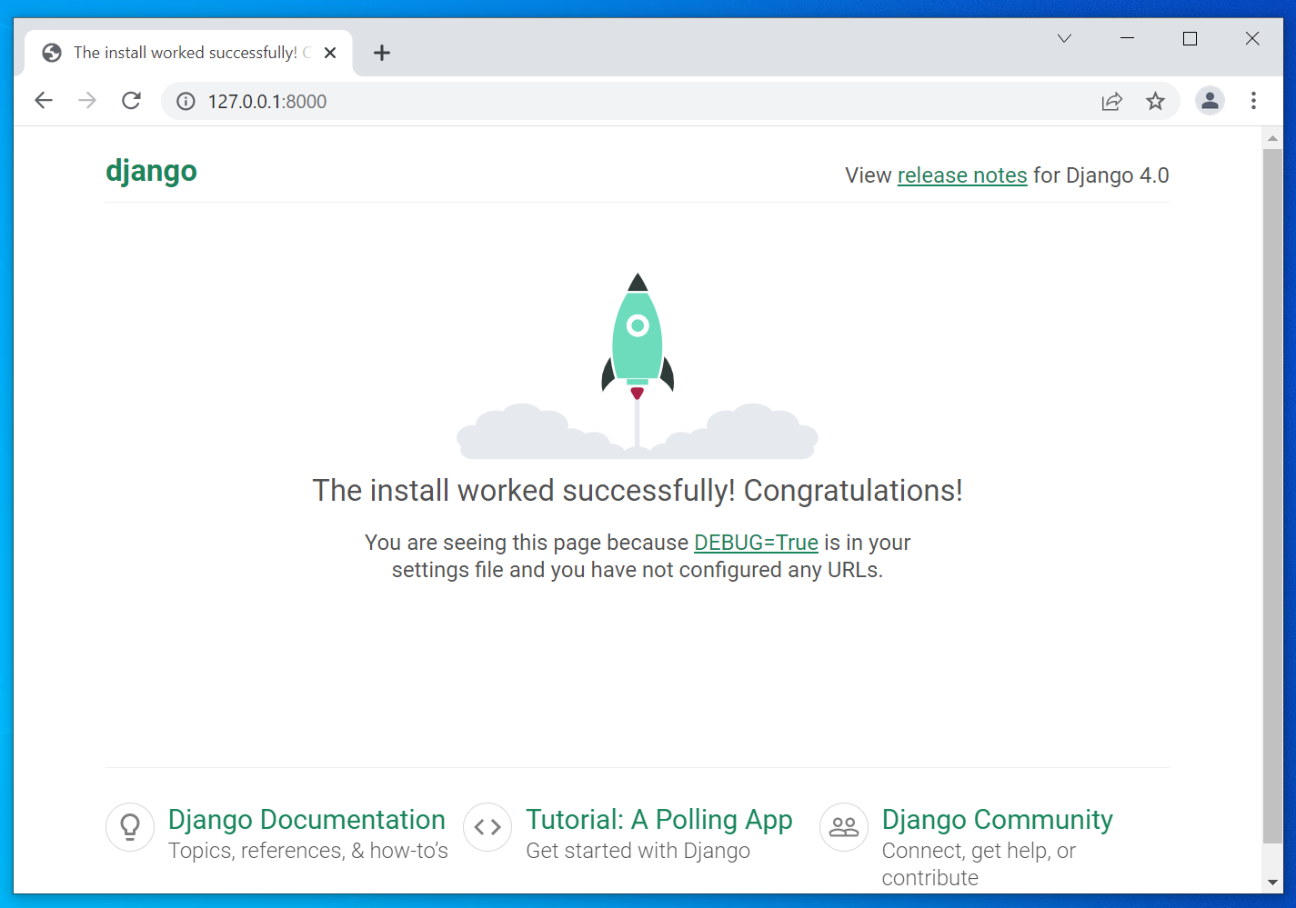

Afterward, to add an app the running server is quit by pressing ctrl+c. Then the startapp command is utilized followed by my new app name of mysite.

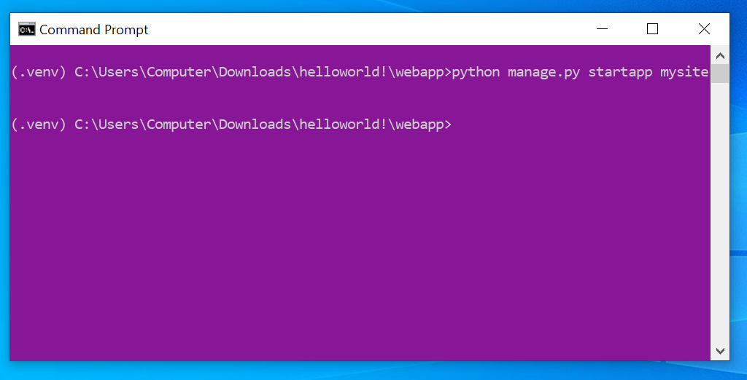

Once the above command is given the below-shown files are created by Django within mysite directory.

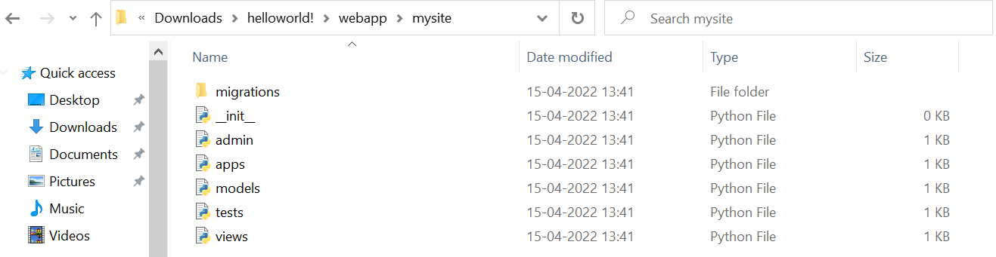

The below screen shows the creation of 1st view. The file views.py inside the mysite is updated as per below (AskPython, 2022).

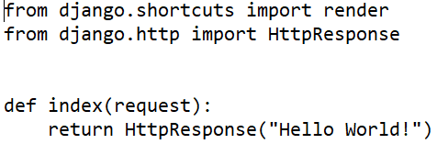

Then, a new file namely urls.py is created inside the mysite directory and the below lines are updated.

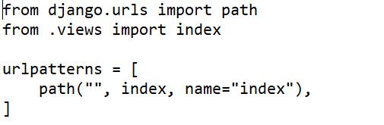

Once necessary updates are performed on all important files. To check the working the Django server is again restarted. An URL is obtained as in the below screen.

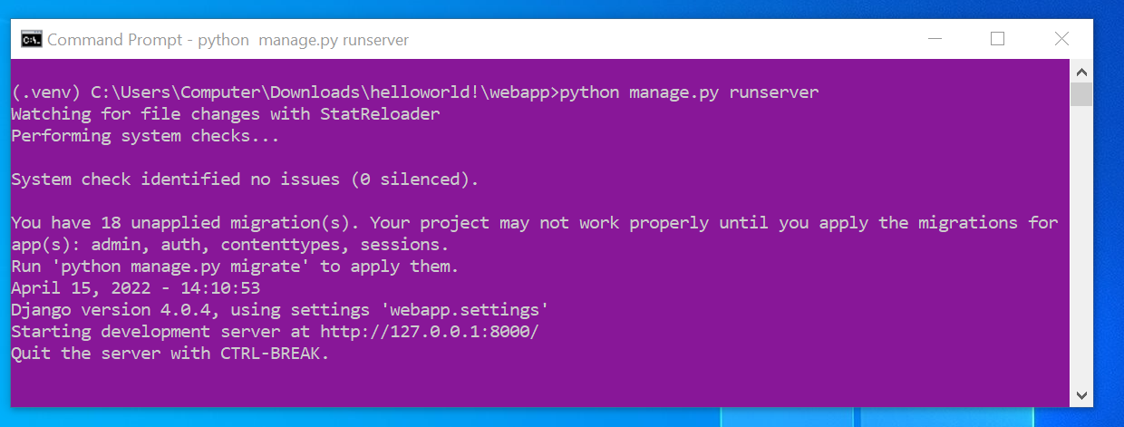

By visiting the URL which was gotten in the web browser the message of Hello World! Is successfully obtained.

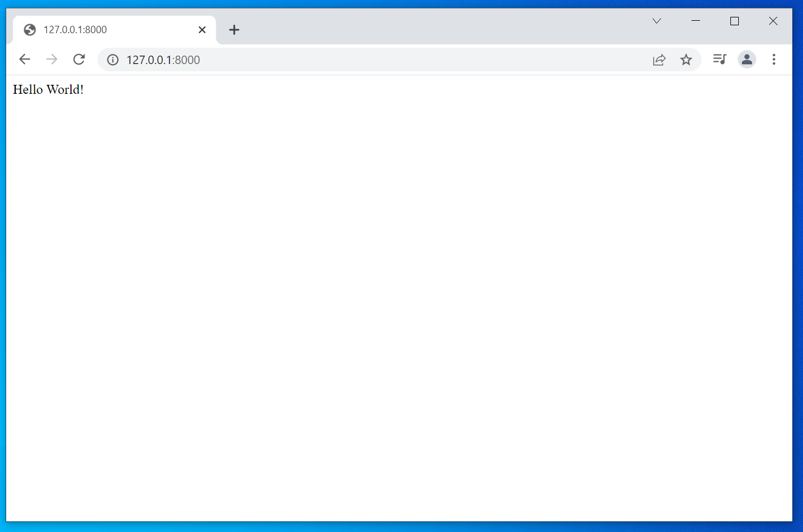

# References

AskPython. (2022). *Django Hello World App – Getting Started With Django*. Retrieved from AskPython: https://www.askpython.com/django/django-hello-world-app

Ogbopina, M. (2019, May 2). *How To Install Django On Windows With Ease*. Retrieved from Medium: https://medium.com/bithubph/how-to-install-django-on-windows-with-ease-7bd599a04b56